Information on CTECS Technical Skills Assessments for Idaho
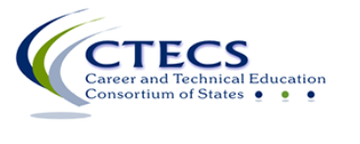

Workplace Readiness Skills Test Characteristics
- 100-item, multiple choice
Idaho Workplace Readiness Skills (WRS) – Mastery 75%
- 60-minute timed test
- $10 per test taker

End-of-Program Assessments Test Characteristics
- 100-item, multiple choice
Idaho Automotive Technology – Mastery 60%
Idaho Collision Repair – Mastery 61%
Idaho Programming and Software Development – Mastery 62%
Idaho Welding – Mastery 62%
- 60-minute timed test
- $8 per test taker

IT Requirements
To ensure the computers you plan to use will meet the testing requirements, please review the IT Checklist on the CTECS website at https://www.ctecs.org/it-requirements.

Sample WRS Assessment
You can take the sample test and/or have your students take the sample test found at http://www.techfluency.org/esess/. The log in process for the sample test is the same as for the actual test. You’ll need to enter information in four blanks, as follows:
Organization | ctecs
First Name | sample
Last Name | sample
Password | sample

Additional Teaching Resources

You can access teaching resources for the WRS assessment on the CTECS website at http://www.ctecs.org/idaho/teaching-resources. Resources include the WRS Assessment blueprint, sample test questions, and resources from other CTECS consortium states.
WRS Assessment Blueprint
